AP Biology Name _________________________
Chapter 21.2, 21.5 and 21.6 Guided Reading: Genomes and Their Evolution
10ed

- Describe four important examples of information that is available through bioinformatics data on the NCBI website.

- What is the goal of scientists who study proteomics?
- How might a human gene microarray chip be of medical importance.

- Describe how the chromosome banding pattern may explain why there are different haploid chromosomes numbers for humans (n =23) and chimpanzees (n=24).

- What is the evolutionary significance of the relationship between the genes on human chromosome 16 and those same blocks of genes on mouse chromosomes 7,8,16, and 17?
- A good summary of several processes involved in genomic evolution can be found in the globin gene families. Label and explain these processes as described in Figure 21.14 in your text.
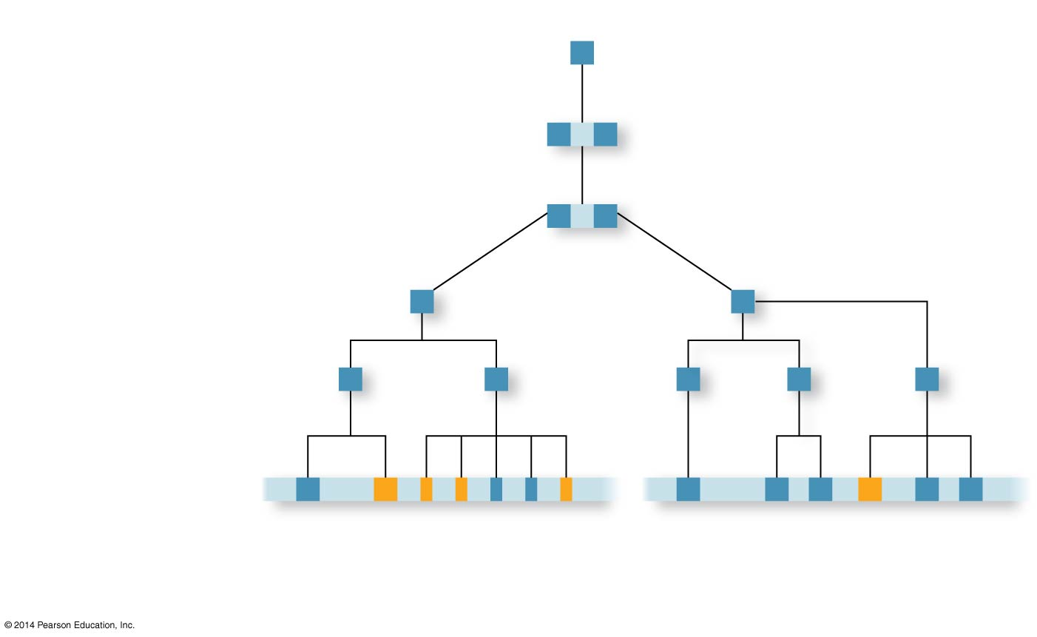
- Using the concept of a protein domain in your answers, explain how exon shuffling can lead to new proteins with novel functions.
- Summarize the genome relationship between the closely related species of humans, chimpanzees, and bonobos?
- Transposable elements contribute to genome evolution in several ways. Describe three.

- When comparing genomes, we find that the more _____________ in sequence the gene and genomes of two species are, the more closely related those species are in their _______________ history.
- What does it mean to say that a gene is highly conserved?
- What is evo-devo, and how does it relate to understanding the evolution of genomes?

- Explain what a homeobox is, and describe how it functions.

